# EXPLORATORY DATA ANALYSIS FOR CUSTOMER SEGMENTATION BY TRANSACTION DATA

# SELECT TOP 10 CUSTOMERS BASED ON TOTAL AMOUNT IN DESCENDING ORDER

top_10 = customer_data[["customer_id","total_no_of_transactions","total_amount_in_dollar"]].sort_values(by='total_amount_in_dollar', ascending=False).head(10)

plt.figure(figsize=(13, 5))

sns.barplot(y="customer_id", x="total_amount_in_dollar", data=top_10, orient='h')

plt.xlabel("Total Amount")

plt.ylabel("Customer ID")

plt.title("Top 10 Customers by Total Amount")

plt.show()

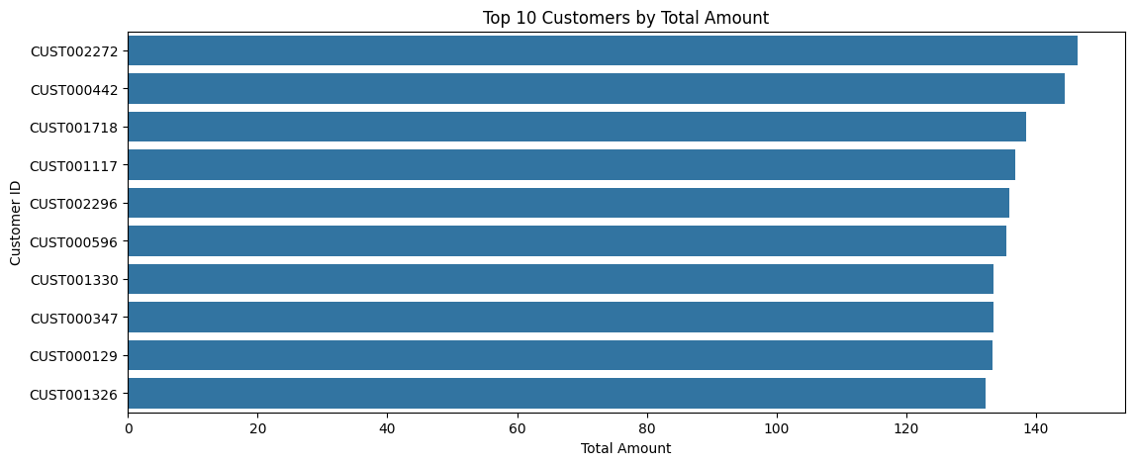

#SELECT TOP 10 CUSTOMERS BASED ON WITHDRAWALS AMOUNT

top_10 = customer_data[["customer_id","withdrawals_amount_in_dollar"]].sort_values(by='withdrawals_amount_in_dollar', ascending=False).head(10)

plt.figure(figsize=(13, 5))

sns.barplot(x="customer_id", y="withdrawals_amount_in_dollar", data=top_10, palette="coolwarm")

plt.title("Top 10 Customers by Withdrawals Amount", fontsize=16, fontweight="bold")

plt.xlabel("Customer ID", fontsize=14)

plt.ylabel("Withdrawals Amount", fontsize=14)

plt.show()

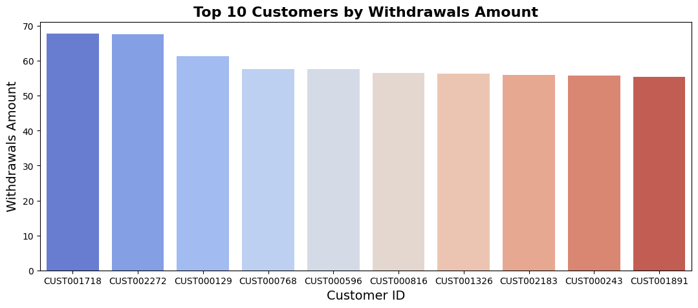

# CREATE A DISTRIBUTION PLOT FOR TOTAL AMOUNT WITH KDE

sns.displot(data=customer_data, x="total_amount_in_dollar", kde=True)

plt.show()

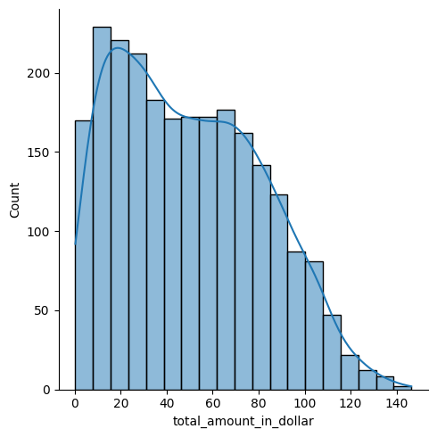

# SELECT TOP 10 CUSTOMERS BASED ON DEPOSITS AMOUNT

top_10 = customer_data[["customer_id","deposits_amount_in_dollar"]].sort_values(by='deposits_amount_in_dollar', ascending=False).head(10)

plt.figure(figsize=(13, 5))

sns.barplot(x="customer_id", y="deposits_amount_in_dollar", data=top_10, palette="Greens")

plt.title("Top 10 Customers by Deposits Amount", fontsize=16, fontweight="bold")

plt.xlabel("Customer ID", fontsize=14)

plt.ylabel("Deposits Amount", fontsize=14)

plt.show()

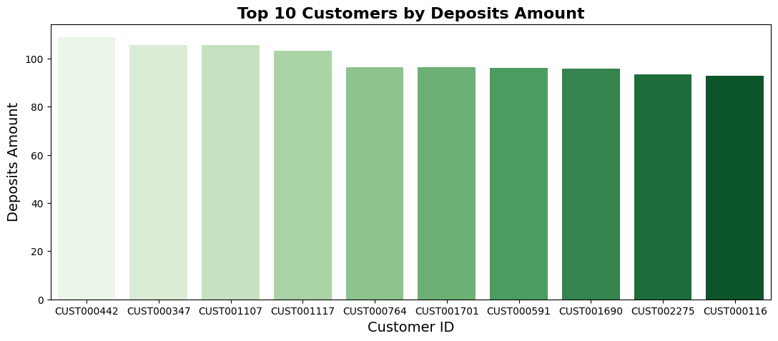

#CHECKING THE CORRELATION FOR NUMERIC COLUMNS USING HEATMAP

correlation_matrix = customer_data[["total_no_of_transactions", "total_amount_in_dollar",

"num_of_deposits", "num_of_withdrawals", "withdrawals_amount_in_dollar", "deposits_amount_in_dollar"]].corr()

plt.figure(figsize=(10, 8))

sns.heatmap(correlation_matrix, annot=True, cmap='coolwarm', fmt='.2f')

plt.title("Correlation Matrix")

plt.show()

